* ***Name:***  Name of company in the S&P500 index
* ***BBRGovernance Pillar Score:*** an absolute assessment of a company’s governance that uses a universally applied 0-10 scale, calculated using a deduction-based approach.
* ***Market Cap - Compound Annual Growth Rate:*** **Market Cap** is the monetary value of all outstanding shares stated in the pricing currency. Capitalization is a measure of corporate size. **Compound Annual Growth Rate** is the smooth Growth rate between two periods. It’s calculated by dividing the value from the most recent time period by the value from the oldest time period, raised to the power of 1/n, where n is the number of periods.
* ***Relative Strength Index:*** An index used for purpose of comparing a security (performance, volatility, etc.) to the market. **Equity:** This is set as a default for the exchange code, regardless of whether or not the equity security is a member of the benchmark index. **Bloomberg terminal:** The IPDF<GO> function can be used to override the relative index and, if applicable, sub-index for the loaded security.
* ***Price Earnings Ratio (P/E):*** Ratio of the price of a stock and the company’s earnings per share. For US and Canada, calculated as Last Price (PR005, PX_LAST) divided by Trailing 12M Diluted EPS From Cont OPS (RR844, T12M_DIL_DES_CONT_OPS) or Diluted EPS From Continuing Ops (IS147, IS_DIL_EPS_CONT_OPS) if only annual earnings exist.
* ***Bloomberg Default Risk:***

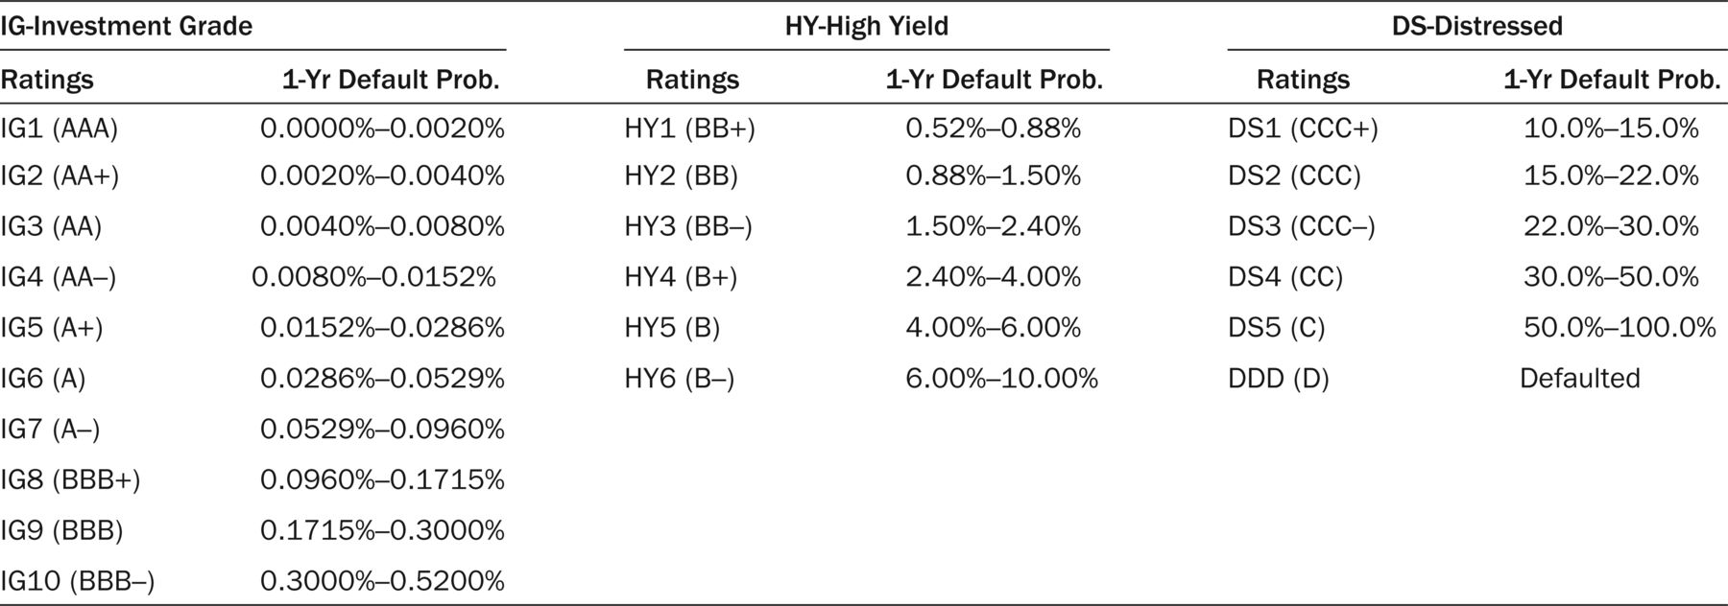

* ***Return Sharpe Ratio:*** A risk-adjusted measure that calculates the excess performance with respect to the risk free rate (in our case, the yield 3 months linked to the currency), per unit of volatility over the time frame. Performance is measured as mean return. The higher the Sharpe ratio, the better the historical ris-adjusted performance. The default time frame is 1 year. Time frame can be changed using Risk Measures.
* ***Fundamental Industry Code:*** Returns the format in which the company reports its financial statements. The available types are Industrial, Bank, Financial, Insurance, Utility, Minicipal General Obligation, REITs, and Municipal Revenue Bond. This field may return different from the industry in which the company operates.
* ***Ticker and Exchange Code:*** This field is the ticker and the exchange code.
* **BEst Target Price:** Price target (fair value) provided by the analyst covering the stock
* ***Total Assets:*** This is the sum of Cash and bank balances, FED funds sold and resae agreement, Investments for Trade and Sale, Net loans, Investments held to maturity, Net fixed assets, Other assets, Customers’ Acceptances and liabilities.
* ***Free Cash Flow:*** Measure of financial performance calculated as operating cash flow minus capital expenditures. Free cash flow (FCF) represents the cash that a company is able to generate after laying out the money required to maintain or expand its asset base. Figure is reported in millions.

Data are collected as of:

* 11/07/2022
* 11/07/2020
* 11/07/2019
* 11/07/2018
* 11/07/2017